# FIELD TRIP REPORTS

Jhjhl;h;lkj;lkj;lkj

## Valpariso

Today, we went on a tour de Valparaiso that covered everything from the central market area in front of the marine building all the way to the top of the hill where we had to ride ‘funiculares’ to travel up the hills.

The first stop we went to was in a central area, before heading to the catholic church de Cristo. This was the first introduction to the age and background culture of the buildings. Most of the buildings are very old and date back multiple centuries. Buildings may be upgraded/renovated but because it is so costly, most buildings are not rebuilt in the case of a fire because the owner can not afford to repair the damages.

The Catholic Church of Christ was something to behold. It was renovated recently by private funds for school or learning purposes. The church takes care of the homeless as well, by providing food for them at certain hours and seemingly a place to stay. When the homeless man approached our tour group, and mentioned to our tour guide to talk about what he had already talked about, it really added depth to what it means to the people of Valparaiso.

Next, we traveled to the residential and very poor part of Valparaiso. The houses seemed very unstable and the electrical issues were pointed out as main sources of fires in the ‘favella’. The buildings were decorated in art, and ruined in graffiti. Some of the art work was some of the most beautiful murals I’ve seen with my own eyes. It made perfect sense when the tour guide said the government supports the artwork and perhaps funds the paintings. Speaking on the part of the graffiti, it seemed endless and nothing was off limits. It seemed like people graffiti just to graffiti, for example I saw tic-tac-toe graffiti, multiple male reproductive parts, and tons of “third eye” pictures.

When we traveled around the city, we rode funiculars or hydraulic systems to travel up very steep hills. It was a very clever use of engineering to solve a transportation problem, and made for great pictures. I would compare it to a tollway, paying some pesos to travel up a hill, hopefully going to the city.

Furthermore, water supply is not necessarily an issue in the rural area of Valparaiso due to the nature of the geographic. The city pumps water to the top of the hill and thus distributes it using gravity to it’s citizens, minimizing the amount of power it takes to supply water to the citizens of Valparaiso. However, the structure of the soil supporting the pipes are weak, foreshadowing major pipe breaks or potential undiscovered leaks already existing.

Figure 1. Restaurant and tourist area of Valparaiso

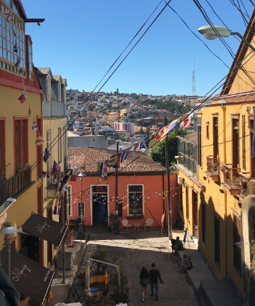

Figure 2. Hired artists graffitiing the walls of public establishments

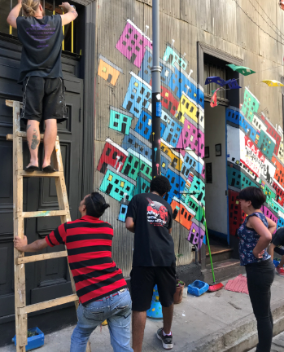

Figure 3. Graffiti art

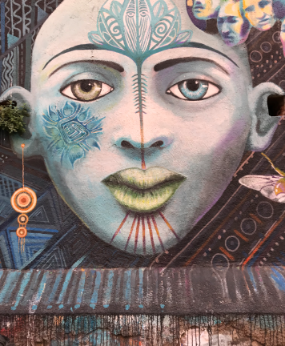

Figure 4. Graffiti art

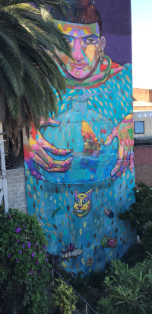

Figure 5. Funicular transportation system

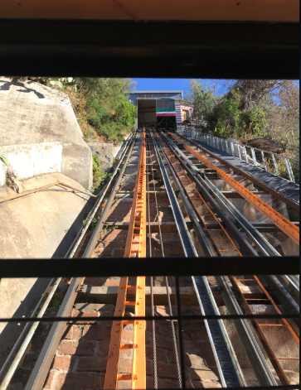

Figure 6. View of the city from the funicular

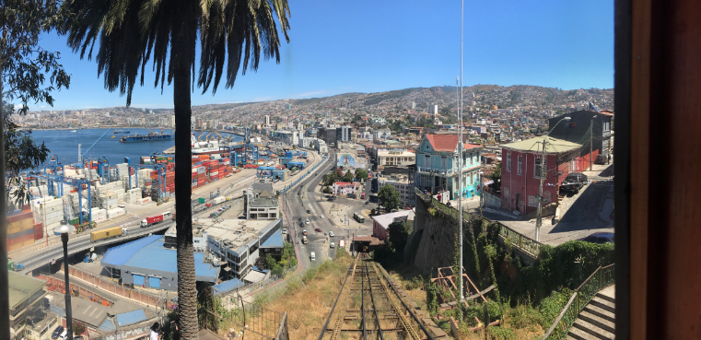

Figure 7. Group photo once the funicular reached the top of the hill

